KAZAKH NATIONAL UNIVERSITY NAMED AFTER AL-FARABI

FACULTY OF CHEMISTRY AND CHEMICAL TECHNOLOGY
Department of physical chemistry, catalysis and petrochemistry

Methodical instructions for laboratory work

STUDY OF THE RATE OF SAPAGENATION OF ACETETETHYL ETHER WITH ALKALINE

ON THE COURSE “PHYSICAL CHEMISTRY”

Approved at the meeting of the department of physical chemistry, catalysis and petrochemistry
dated “ ___ ” _____ 202___, protocol No. ___

Head of the department ________Ye.A. Aubakirov

.

Almaty, 2023
STUDY OF THE RATE OF SAPONIFICATION OF ACETIC ETHYL ESTER WITH ALKALI

Chemical reactions proceed at different rates. The study of the rate of chemical reactions is called chemical kinetics.
The theoretical consideration of chemical reactions occurring in solutions is much more complicated than reactions in gases. This is due to the fact that liquid molecules are at closer distances, when the interaction forces between them cannot be considered small or even absent, which is often allowed in gases. In solutions, we cannot neglect the interaction of the reagent molecules with the solvent molecules, as well as with the molecules of extraneous substances that are not directly involved in the reaction.
The experimentally observed patterns of reaction rates in solutions are not the same for reactions of different types. In some of them, the solvent does not play a significant role, while in others, on the contrary, it strongly affects the reaction rate. Extraneous substances accelerate, slow down, or have no effect on the rate of various reactions.

Performance Objectives:

1.Experimentally obtain the kinetic regularities for the reaction of saponification of ester with alkali.
2.Determine the average value of the rate constant of this reaction at different temperatures.
3.Calculate the activation energy of the process of saponification of ester with alkali.

THEORETICAL PART

Reaction rate

The rate of a chemical reaction for a certain component (WI) is the change in the amount of this component per unit of time in a unit of reaction space:

$W_{i}=±\frac{1}{R}\frac{{dn}_{i}}{dt}$ | (1)
where n_{i} is the amount of the component, t is the time, R is the size of the space in which the reaction is localized.
For a homogeneous reaction, the reaction space is the volume of the reaction system (V). Hence for a homogeneous reaction
$$A_{1}+A_{2}→A_{1}^{'}+A_{2}^{'}$$
$-\frac{1}{V}\frac{{dn}_{A_{1}}}{dt}=-\frac{1}{V}\frac{{dn}_{A_{2}}}{dt}=+\frac{1}{V}\frac{{dn}_{A_{1}^{'}}}{dt}=+\frac{1}{V}\frac{{dn}_{A_{2}^{'}}}{dt}$ | (2)

In the case of a heterogeneous reaction, the interface S acts as the reaction space, and then:
$$W_{i}=±\frac{1}{S}\frac{{dn}_{i}}{dt}$$ | (3)
For a homogeneous process, if the volume of the reaction system does not change, the volume (V) in equation (2) can be brought under the differential sign:
$$W_{i}=±\frac{d(\frac{n_{i}}{V})}{dt}=±\frac{{dC}_{i}}{dt}$$ | (4)
Thus, for a homogeneous chemical process running at a constant volume, the process rate for a certain component is the change in the concentration of this component per unit time.
Graphically, the reaction rate is expressed by the value of the slope of the tangent at the point of the kinetic curve C=f(t), corresponding to the selected time t (Fig. 1, 2).
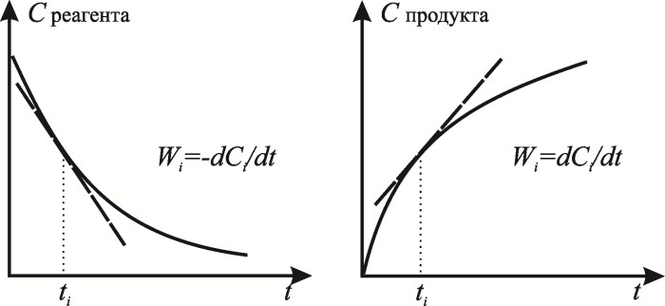

Figure 1 | Figure 2
If the reaction follows the stoichiometric equation
$${ν_{1}A}_{1}+{ν_{2}A}_{2}→{ν_{1}^{'}A}_{1}^{'}+{ν_{2}^{'}A}_{2}^{'}$$
then between the change in the number of moles of substances and, consequently, the change in the concentrations of the reagents, the relation:
$-\frac{1}{ν_{1}}\frac{{dn}_{A_{1}}}{dt}=-\frac{1}{ν_{2}}\frac{{dn}_{A_{2}}}{dt}=+\frac{1}{ν_{1}^{'}}\frac{{dn}_{A_{1}^{'}}}{dt}=+\frac{1}{ν_{2}^{'}}\frac{{dn}_{A_{2}^{'}}}{dt}$ | (2)
The reaction rate is always positive, but the signs (+) or (-) are used depending on whether the change in the concentration of the starting substances (-) or reaction products (+) is used to study the rate of this process. The reaction rate is expressed as the derivative of the concentration with respect to time for any substance involved in the reaction. The initial substances are consumed, and the reaction products are formed in equivalent amounts in accordance with their stoichiometric coefficients; therefore, when determining the reaction rate, there is no need to monitor the change in the concentration of all interacting substances.

Kinetic equation
The equation describing the dependence of the rate of a chemical process on the concentration of the components of the reaction mixture is called the kinetic equation of the process (differential reaction rate equation).
According to the law of mass action, the rate of an elementary reaction is equal to the product of the reaction rate constant (k) and the product of the concentrations of the starting substances, taken in powers equal to the stoichiometric coefficients.
In general, the rate of a reaction proceeding in a reaction:
$${n_{1}A}_{1}+{n_{2}A}_{2}→n_{3}A_{1}^{'}+{n_{3}A}_{2}^{'}$$
can be adequately represented by several equations:
$$W=-\frac{1}{n_{1}}\frac{{dC}_{A}}{dt}=-\frac{1}{n_{2}}\frac{{dC}_{B}}{dt}=\frac{1}{n_{3}}\frac{{dC}_{C}}{dt}=\frac{1}{n_{4}}\frac{{dC}_{D}}{dt}$$
where n₁, n₂, n₃, n₄ are stoichiometric coefficients.

The dependence of the velocity on the concentration of the initial substances is expressed by the law of mass action:
$$W=kC_{A}^{n_{1}}C_{B}^{n_{2}}$$ | (5)

where k is the rate constant of the reaction, n₁ and n₂ are numbers indicating the particular order of the reaction in components A and B, respectively. The total reaction order is: n=n₁+n₂. Dependence (5) is called the basic postulate of chemical kinetics: the reaction rate at each moment of time is proportional to the product of the concentration of reactants raised to a certain power.

An important characteristic in chemical kinetics is the rate constant. Its physical meaning is that, provided that the concentration of reactants is equal to unity (C_{A}=C_{B}=1), for homogeneous reactions the rate constant is equal to the reaction rate W=k¸ and for heterogeneous reactions W≠k. The dimension of the rate constant is determined by the kinetic equation by which it is calculated depending on the order of the reaction. In general terms, this can be represented as follows: {k}=(conc) ^{n+1} * (time)⁻¹, where n₁ is the order of the reaction.
The form of the kinetic equation and the dependence of the reaction rate on the concentration of reagents that it characterizes follow from a certain mechanism of the process and specific conditions for its implementation. Therefore, each kinetic equation is valid only in a certain range of specified conditions (temperature, pressure, composition of the reaction mixture, etc.). The dimension of the reaction rate constant depends on the order of the reaction (table).

Reaction order | Dimension of the rate constant | Example
0 | [conc] [ time]⁻¹ | (mol/l)·sec⁻¹
1 | [time]⁻¹ | sec⁻¹
2 | [conc]⁻¹ [time]⁻¹ | (mol/l)⁻¹· sec ⁻¹
3 | [conc]⁻² [time]⁻¹ | (mol/l)⁻²·sec⁻¹
n | [conc]^{-(n-1)}[ time]⁻¹ | (mol/l)^{-(n-1)}·sec⁻¹

Order and molecularity
The order of the reaction for a given component is the exponent in the kinetic equation of the form:
$$W=kC_{A}^{n_{1}}C_{B}^{n_{2}}$$
where n₁, n₂ are the reaction orders with respect to substances A and B.
It is important to note that the exponents ni in the kinetic equation are not stoichiometric coefficients ν_{i} of the chemical reaction equation, but must be determined from experimental measurements of the reaction rate.
The order of the reaction is a formal value, it can be positive, negative, integer, fractional, and also equal to zero. The general order is equal to the sum of the exponents:
n = n₁ + n₂ …
The magnitudes of the reaction orders cannot be assigned any physical meaning, for this it is necessary to find out the mechanism and analyze how this kinetic equation follows from it.
For elementary reactions or elementary stages of reactions, ni coincides with stoichiometric coefficients showing how many molecules of a given substance simultaneously participate in an elementary reaction.
The molecularity of reactions is the number of particles that take part in an elementary act. Reactions are monomolecular, bimolecular and trimolecular. Participation in an elementary act of more than three particles is extremely unlikely.
Most chemical reactions are a combination of several sequential and parallel elementary stages, that is, a complex mechanism takes place, therefore, molecularity and order, in general, do not coincide. Thus, the order of the reaction indicates only the exponent in which the concentration of a given substance enters the kinetic equation, and the molecularity indicates the mechanism of interaction in the elementary act.

Unilateral second order reactions

For these reactions, 2 main cases are possible: monosubstrate and bisubstrate, in which one or two starting substances are involved, respectively.
Type 1:
Monosubstrate
a) 2A → products
The kinetic equation has the form:
$$-\frac{1}{2}\frac{{dС}_{A}}{dt}=k∙C_{A}^{2}$$ | (6)

$$-\frac{{dС}_{A}}{dt}=2k∙C_{A}^{2}$$ | (7)

The factor 2 appears because two molecules A are removed in each act of the reaction. After integration, we get:
$$k=\frac{1}{2t}\left(\frac{1}{C_{A}}-\frac{1}{C_{0,A}}\right)$$ | (8)
Equation (8) in linear form has the form:
$$\frac{1}{C_{A}}=\frac{1}{C_{0,A}}+2kt$$ | (9)
Therefore, the dependence 1/С_{A} = f(t) is a straight line with a positive slope equal to 2k (Figure 3).
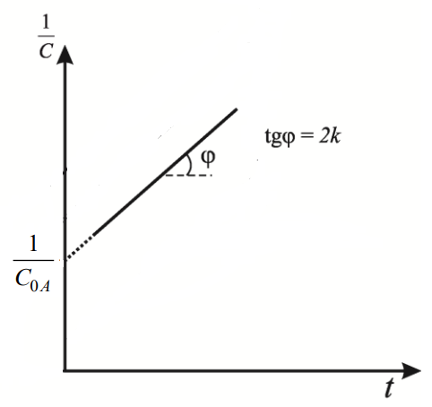
Figure 3
Half time:
$$t_{1/2}=\frac{1}{2kC_{0,A}}$$
Thus, in contrast to first-order kinetics, the half-life in a second-order reaction depends on the initial concentration of the reactant.
Type 2:
Bisubstrate reactions of the 2nd order:
A + B → products
This reaction can be considered under different conditions: with equality (b) and inequality (c) of the initial concentrations of the reagents.
b) The initial concentrations of starting materials A and B are the same:
C_{0,A} = C_{0,B}.
This case is mathematically reduced to type 1 (a), but instead of 2k in equation (9), just k appears:
$$-\frac{dC_{A}}{dt}=k∙C_{A}^{2}$$
$$k=\frac{1}{t}\left(\frac{1}{C_{A}}- \frac{1}{C_{0,A}}\right)$$ | (10)

in linear form, equation (10) has the form (Fig. 5),
$$\frac{1}{C_{A}}=\frac{1}{C_{0,A}}+kt$$ | (11)

Thus, to estimate the rate constant, it is necessary to plot the dependence 1/С_{A} – t.
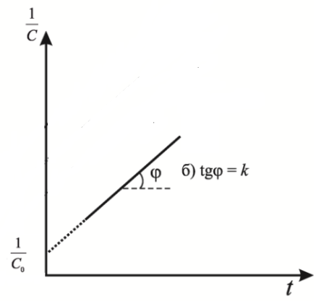
Figure 4
Half life:
$$t_{1/2}=\frac{1}{kC_{0,A}}$$ | (12)

c) The initial concentrations of the reagents are not the same С_{0А} ≠ С_{0В}, the kinetic equation has the form:
$$W=-\frac{dC_{A}}{dt}=k∙C_{A}∙C_{B},$$
after integrating this equation:
$$k=\frac{1}{t(C_{0,A}-C_{0,B})}ln\frac{C_{0,B}∙C_{A}}{C_{0,A}∙C_{B}},$$ | (13)

where, С_{A} and С_{B} are the current concentrations of substances A and B.
In linear form, equation (13) has the form:

$ln\frac{C_{A}}{C_{B}}=ln\frac{C_{0,A}}{C_{0,B}}+(C_{0,A}-C_{0,B})kt$. | (14)
Thus, the ln(C_{A}/C_{B}) dependence is a linear function of time t, and k can be determined from the slope tangent (Fig. 5).

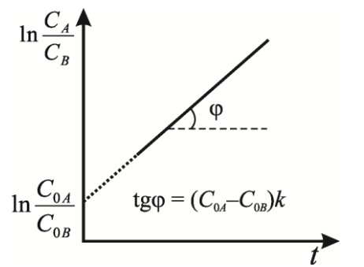
Figure 5

DEPENDENCE OF THE RATE OF A CHEMICAL REACTION ON TEMPERATURE
The rate of most chemical reactions (with the exception of third-order and enzymatic reactions) increases sharply with increasing temperature. Analysis of the kinetic equation:
shows that the change in the reaction rate with temperature can be associated with a change in three quantities: the rate constant, the concentration of the reactants, and the order of the reaction. The effect of temperature on the reaction rate is mainly associated with a change in the reaction rate constant.
There is an empirical rule of Van't Hoff, according to which: an increase in temperature by 10 ° causes an increase in the rate constant by 2–4 times.
The temperature coefficient of the reaction rate γ makes it possible to approximately estimate the change in the reaction rate with an increase in temperature by a certain number of degrees.
The van't Hoff rule gives a semi-quantitative description of the effect of temperature on the reaction rate. More precisely, the dependence of the rate constant on temperature characterizes the Arrhenius equation, which in differential form has the form:

Methods for calculating activation energies

1. If only two rate constants are measured at two temperatures, then the activation energy is calculated from the equation:

or,

2. According to the temperature dependence of the reaction rate constant (Fig. 6).

If we construct the dependence lnk = f(1/T) (Fig. 6), we get a straight line with a negative slope equal to Ea/R, cutting off a segment equal to lnA₀ from the y-axis.
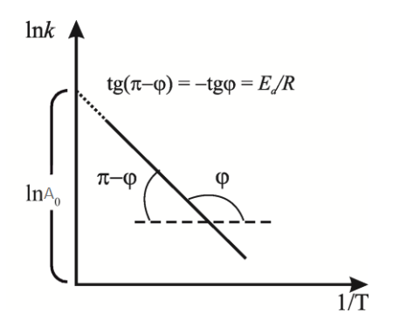

Figure 6.
However, in practice, A₀ is not determined in this way, since the extrapolation to infinite temperature is too long to obtain an exact value. Therefore, A₀ is determined by substituting the value of the activation energy and the rate constant at a certain temperature into the equation.

Kinetics of the saponification reaction of esters
One of the first kinetically studied reactions occurring in solution is the reaction of bimolecular saponification of esters, for example, saponification of ethyl acetate (acetic ethyl ester) with alkali:

СН₃СООС₂Н₅ + NaОН = СН₃СООNa + С₂Н₅ОН

The reaction of saponification of esters with a base is a second-order reaction, is practically irreversible and proceeds at a noticeable rate.
An experimental study of the kinetics of the reaction of saponification of ether with alkali in an aqueous solution is carried out at unequal initial concentrations of ether and alkali; the amount of alkali is taken in a slight excess compared to the amount of ether. The reaction rate is studied by observing the change in the concentration of alkali during the course of the process. To do this, at certain intervals, samples of the reaction mixture of the same volume are titrated with an acid solution with a precisely established concentration and the concentration of alkali is calculated at different points in time. The reaction of saponification of the ester with alkali practically ends at room temperature after 12–14 hours. To speed up this process and determine the amount of unreacted alkali, that is, its excess compared to ether, after observing the course of the reaction for 35–40 minutes, the reaction mixture is heated for 10–15 minutes at a temperature of 90 ºС with a reflux condenser.
As can be seen from the data below, the reaction rate does not change with a change in the chemical nature of the base and changes little with a change in the initial concentration of the base (Table 1).
Table 1
Influence of the nature of the base and its initial concentration on the rate constant of the saponification reaction of acetic ethyl ester
Initial base  concentration, mol/l | Reaction rate constant, l/(mol min)
 | Base
 | NaOH | KOH | Ba(OH)₂
0,0125 | 6,21 | - | 6,35
0,0250 | 6,32 | 6,46 | 6,29
0,0500 | 6,36 | 6,65 | 6,23

The values of pre-exponential factors, activation energies, steric factors of the reaction of saponification of esters with alkalis are presented in Table. 2.
The transition to other ethers shows (Table 2) that a change in the number of atoms in the hydrocarbon radical does not lead to a significant change in the activation energy and the overall kinetic characteristic of the process. This indicates the reliability of the ionic mechanism of the ester saponification reaction.

Table 2
Kinetic parameters of the ester saponification reaction

Reaction parameter | Ether
 | СН₃СООС₂Н₅ | СН₃СООС₃Н₇ | СН₃СООС₄Н₉
Pre-exponential factor, cm³/(mol·s) | 1,38·10¹⁰ | 1,94·10¹⁰ | 2,12·10¹⁰
Activation energy, kJ/mol | 46,9 | 47,3 | 47,7
Steric factor | 0,05 | 0,07 | 0,07
The effect of temperature on the reaction rate of saponification of acetic ethyl ester with alkali is presented in table. 3.
Table 3
Effect of temperature on the rate of saponification reaction
СН₃СООС₂Н₅
T, ºС | k, cm³/(mol s) | k, l/(mol min)
0 | 19,5 | 1,17
20 | 84,7 | 5,08
25 | 109,3 | 6,56

An experimental study of the kinetics of the reaction of saponification of ether with alkali in an aqueous solution is carried out at unequal initial concentrations of ether and alkali; the amount of alkali is taken in a slight excess compared to the amount of ether. The reaction rate is studied by observing the change in the concentration of alkali during the course of the process. To do this, at certain intervals, samples of the same volume are titrated with an acid solution with a precisely established concentration and the concentration of alkali is calculated at different points in time.
The rate of the saponification reaction at any time is proportional to the concentration of ether and alkali and is determined by the equation:

The rate constant of the ester saponification reaction has the dimension l/(mol∙min) and is calculated by the equation:
where C⁰ - initial concentrations of alkali and ether;
C_{x} is the concentration of alkali and ether that have reacted by the time t;
k is the rate constant of the second order reaction.
If the reactants are taken in equivalent quantities, the equation will take the form:

and after integration:
.

EXPERIMENTAL PART
Equipment and reagents
The following equipment and reagents are required to complete the job:
1. Thermostat or water bath, which maintains a constant temperature (as directed by the teacher).
2. Two round flasks of 100-150 ml, one of which (with a ground stopper) is for an ether solution, and the other (with an ordinary rubber stopper) is for an alkali solution.
3. Two conical Erlenmeyer titration flasks.
4. Burette for titration.
5. Measuring cylinder for 50 or 100 ml.
6. 10.0 ml pipette for sampling.
7. Reflux condenser.
8. A solution of acetic ethyl ether with a concentration of 0.025 N.
9. Alkali solution with a concentration of 0.025 N.
10. A solution of hydrochloric acid with a concentration of 0.025 N.
11. Phenolphthalein solution.
12. Distilled water.

Methodology for performing work

Into one of the flasks (200 ml) pour 50 ml of an ester solution (0.025 N) from a burette, into the other 50 ml of an alkali solution (0.025 N). The flasks are stoppered and placed in a thermostat with a given temperature (from 25 to 45°C). After 10-15 min. the alkali solution is poured into ether, and the flask with ether is not removed from the thermostat. At the moment of mixing the solutions include a stopwatch. Samples with a volume of 10 ml are taken with a pipette after about 5, 10, 20, 30, 40, 60, 80 minutes. Each sample is poured into 15 ml of 0.025 N HCl. An excess of HCl is titrated with an alkali solution (0.025 N) in the presence of phenolphthalein. If for titration of a sample of V ml of a sample mixed with acid N1 of the normal volume of V1 ml, an alkali solution N2 of the normal volume of V2 ml is used. Then the following formula is used::
$N_{1}V_{1}=\left(C_{0}-C_{x}\right)V+N_{2}V_{2}$
from here
$C_{0}-C_{x}=\frac{N_{1}V_{1}-N_{2}V_{2}}{V}$
$C_{x}=C_{0}-\frac{N_{1}V_{1}-N_{2}V_{2}}{V}$
Using these values, the calculation of the reaction rate constant is carried out according to the equation:
$k=\frac{1}{2t}\frac{C_{x}}{C_{0}(C_{0}-C_{x})}$
since the reactants are taken in equivalent quantities.
Table 4
Experimental data and results of their processing
№ measurements | Time interval from the beginning of the reaction, min. | Volume of NaOH used for sample titration, ml | С_{О}-С_{Х}  alkalis | С_{Х} | Rate constant

According to the obtained experimental data, it is necessary:
1) calculate the values of the reaction rate constant for each moment of time according to the equation;
2) build a kinetic curve 1/С=f(t) (dependence of alkali concentration on the reaction time);
3) calculate the values of the activation energy of the reaction for the temperature interval according to the equation;
4) graph of dependence lnk=f(1/T). The values of the activation energy and the multiplier in front of the exponent, found on this graph;
5) comparison of the obtained kinetic characteristics with reference data.

QUESTIONS FOR SELF-CHECKING
1. What is called the rate constant of a chemical reaction? What is the reaction order?
2. What is the order of the saponification reaction of ethyl acetate with alkali?
3. Give an equation for calculating the rate constant of a second-order reaction in the case of different concentrations of reactants.
4. How does temperature affect the rate of a chemical reaction?
5. Give an equation for calculating the activation energy of the reaction of saponification of ethyl acetate with alkali. What is the limiting step in the saponification process?

